Fish do not need Visas: the transboundary nature of the world’s exploited marine fish species

DRAFT DO NOT SHARE

Authors: Juliano Palacios-Abrantes1, Gabriel Reygondeau1,2, Colette Wabnitz1,3 and William W.L. Cheung1

Affiliations: 1Institute for the Oceans and Fisheries, University of British Columbia, Vancouver, Canada, 2Yale University, New Haven, Connecticut, USA, 3Stockholm Resilience Centre, Stockholm University, Stockholm, Sweden

# Main Article

Distributions of marine species around the world are not bounded by human-made boundaries; rather shaped by contemporary biotic and abiotic factors, as well as their evolutionary history (*1*, *2*). Thus, a species can be cosmopolitan and have a broader distribution like the spiny dogfish (*Squalus acanthias*), or endemic like the masu salmon (*Oncorhynchus masou*) who’s distribution is limited to the Japanese coast (*2*). However, management of living marine resources is predicated on the definition of “stocks” that are delineated by human-made spatial boundaries that often do not correspond to biologically-meaningful population units (*3*, *4*). The delineation of Economic Exclusive Zones (EEZs) under the United Nations Convention on the Law of the Seas (UNCLOS) in the early 80s, for instance, established political boundaries across the distribution of many species, creating shared species between nations. Theories and empirical experience demonstrate fisheries targeting resources that straddle between political boundaries complicate fisheries management and potentially reduce its effectiveness to achieve stated objectives (*5*). For example, environmental fluctuation leading to changes in stock distribution (*6*) and fishing quotas set by different nations for a shared fishery resource have led to conflict (*7*). Moreover, climate change, which is shifting species distributions, is likely to exacerbate this type of conflict (*8*) and presents further challenges for fisheries management (*9*).

Forty years after the formal adoption of UNCLOS, accurate estimates of the number of exploited marine species that are shared by 2 or more neighboring coastal nations (hereafter called transboundary species (*6*)) in the world is still unclear. Caddy in 1997 estimated that there could be up to 1,500 transboundary fish species in the world. However, such estimation lacked a proper assessment due to limited information on the distribution of species at the time (*10*). More recently, Teh and Sumaila (2010) estimated that 206 species can be considered shared, accounting for a total catch of 34.2 million tones and a global landed value of USD 30.7 trillion. Such analysis was based on a literature review of shared species and did not include a mechanistic way of determining the transboundary nature of the species (*11*). In here, we overlay the known distribution of **968** commercially valuable marine fish species and the EEZ of 153 coastal countries to identify those that are shared between neighboring EEZs and determine their contribution to the world’s fisheries catch and revenue.

We developed a four-criteria methodology to determine if a species was transboundary (see Methods). The first criteria consisted in only considering shared species between neighboring EEZs, rather than the specie’s extended distribution. For the second criteria we considered a species to be present in a 0.5^{} x 05^{} grid cell if all data sources predicted positive occurrence. Current species distributions were predicted from occurrence records obtained from publicly available observational databases of the world’s marine species and two structurally distinct species distribution models (*12*, *13*). The third criteria determined whether the species were exploited at the grid cell using spatially explicit catch data (*13*). A species was kept in a grid cell if both predicted species occurrences and catch data were positive. Finally, the last criteria determined a spatial threshold to confirm that a species occurs in both neighboring EEZs. Once transboundary species were identified, we estimated their contribution to fishing landings and revenues using the *Sea Around Us* database (*13*) and categorized them according to catch trends (*14*). We carry out the analysis at the species level, rather than stocks (populations within a species), due to lack of stock-specific spatial and ecological information on all of the fished species (*11*).

## Results and discussion (~1000 words)

We identified **633** transboundary species in the world, more than double the number previously estimated (*11*), accounting for **65.4%** of the species analyzed (Fig. 1A). Between 2005 and 2014, national fleets targeting shared species within EEZs landed an average of **69.2** million tonnes, representing **64%** of the EEZ-global catch, and generating USD **79,745** million in fishing revenue. This is equivalent to **49.8%** of the global revenue of the same period. These values are higher than previously estimated reinforcing the importance of these species at the global level (*11*).

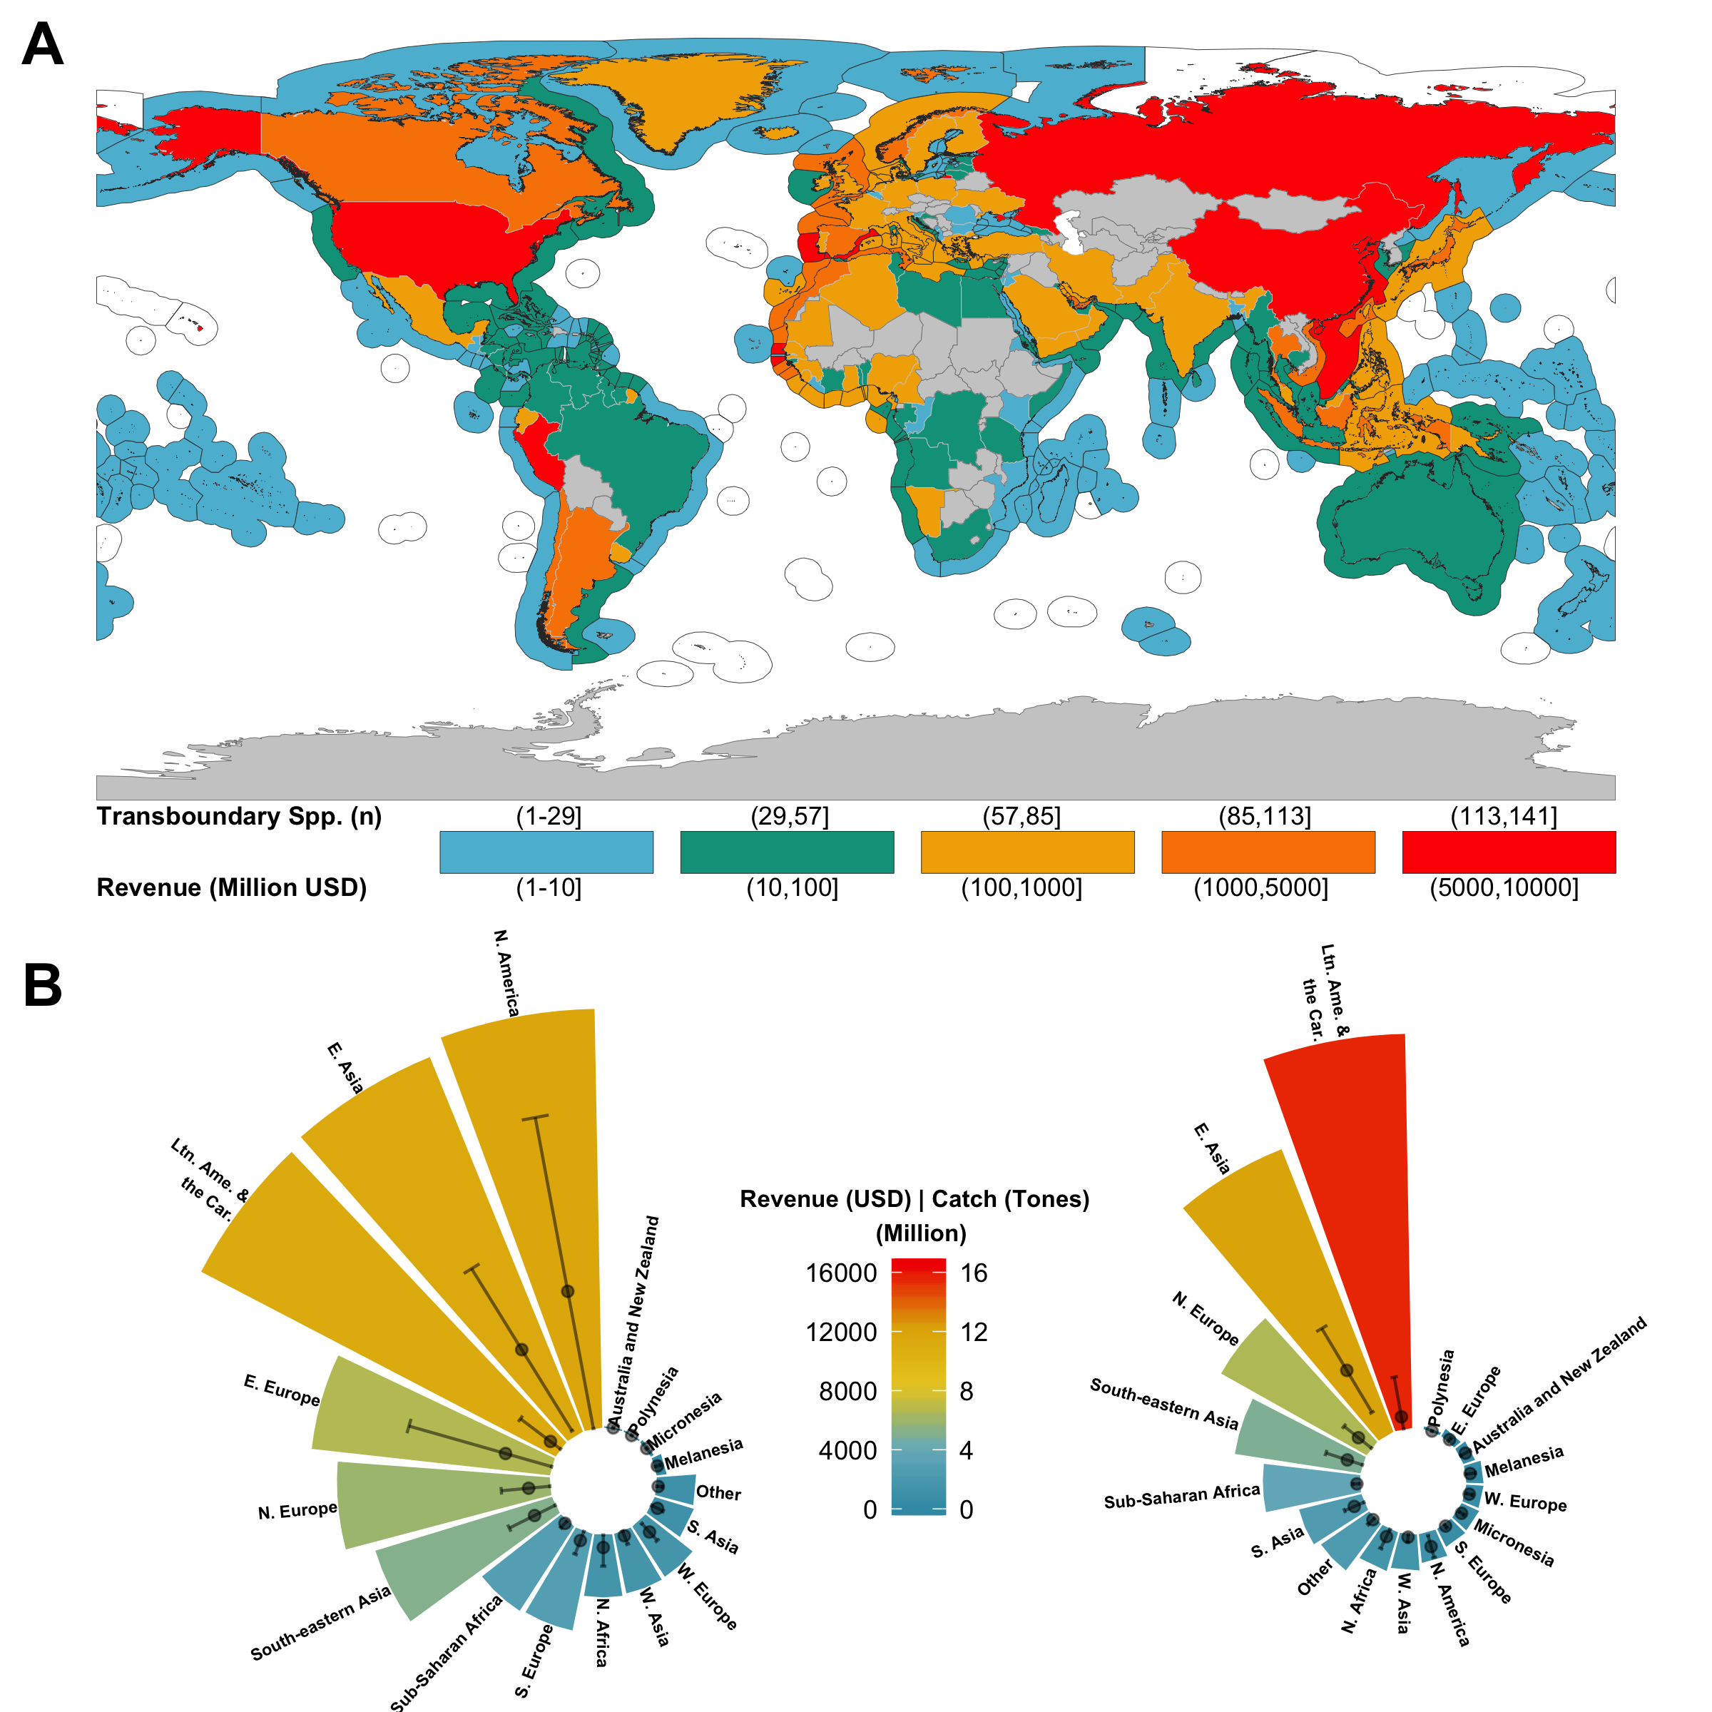

**Fig. 1 Number of transboundary species and they contribution to fishing catch and revenue.** A) The number of species is represented in the EEZ while revenue from these species fished within the EEZ is represented in the land polygon. B) Regional revenue (left) and catch (right) contribution of tranbsoundary species. Points = mean +- sd.

Transboundary species are particularly important for Northern America (mean = 3,901 $±$ 4,497 million USD) and Eastern Asia (mean = 2,827 $±$ = 2,667 million USD), significantly differing from other regions in terms of revenue (one-way ANOVA; *F*(16,157) = 4.91, *p* < 0.001, $α$ = 0.05) (Fig 1B). The large variation in revenue from these regions is driven by China (USD 6,279 million), in E. Asia and the US (USD 9,605 million) in N. America who contribute 55% and 83% to the region’s revenue, respectively. Russia (USD 6,361 million), Peru (USD 5,211) and Japan (USD 3,369) complete the top five countries with more revenue from transboundary species. These five nations are responsible for 30% of the global revenue from transboundary species. Peru and Russia, responsible for the two largest fisheries in the world (*15*), lead the production of transboundary species harvesting over 5,000 thousand tones (**Supplemental figure Trans_Catch_MAP**). Peru’s catches come mainly from Peruvian anchoveta (*Engraulis ringens*), shared with Chile, accounting for 79% of the transboundary species production. Similarly, Russia shares the Alaskan polllock (*Theragra chalcogramma*) fishery with both Japan and the US. Despite this, catches are only significantly different in E. Asia (one-way ANOVA; *F*(16,155) = 3.341, *p* < 0.001, $α$ = 0.05), with China, the world’s top fish producer with 15.3 million tons landed in 2016 (*15*) getting around 1/3 of its capture from transboundary species, followde by Japan (4.2 million tonnes) and South Korea (2.3 million tonnes).

Effective management of shared species is a challenging process as it often requires countries to agree on mutual targets in order to achieve sustainable harvest (*6*). We found significant differences in the exploitation rate of transboundary species (one-way ANOVA *F*(5,446), *f* = 324.5, *p* < 0.001, $α$ = 0.05; Tukey’s post hoc test *p* < 0.05 for all) with most species fished at levels below 50%, sometimes lower than 10%, of their historical maximum peak (Fig.2). Countries that are harvesting at this rate today (Category C) should be paying extra care in the management of these species. This is the case of coastal nations in all continents, but Oceania, with no significant difference between continents (one-way ANOVA *F*(5,443), *f* = 1.24, *p* = 0.289, $α$ = 0.05), suggesting that the current global exploitation rate of transboundary species could be over the maximum sustainable yield (*16*, *17*).

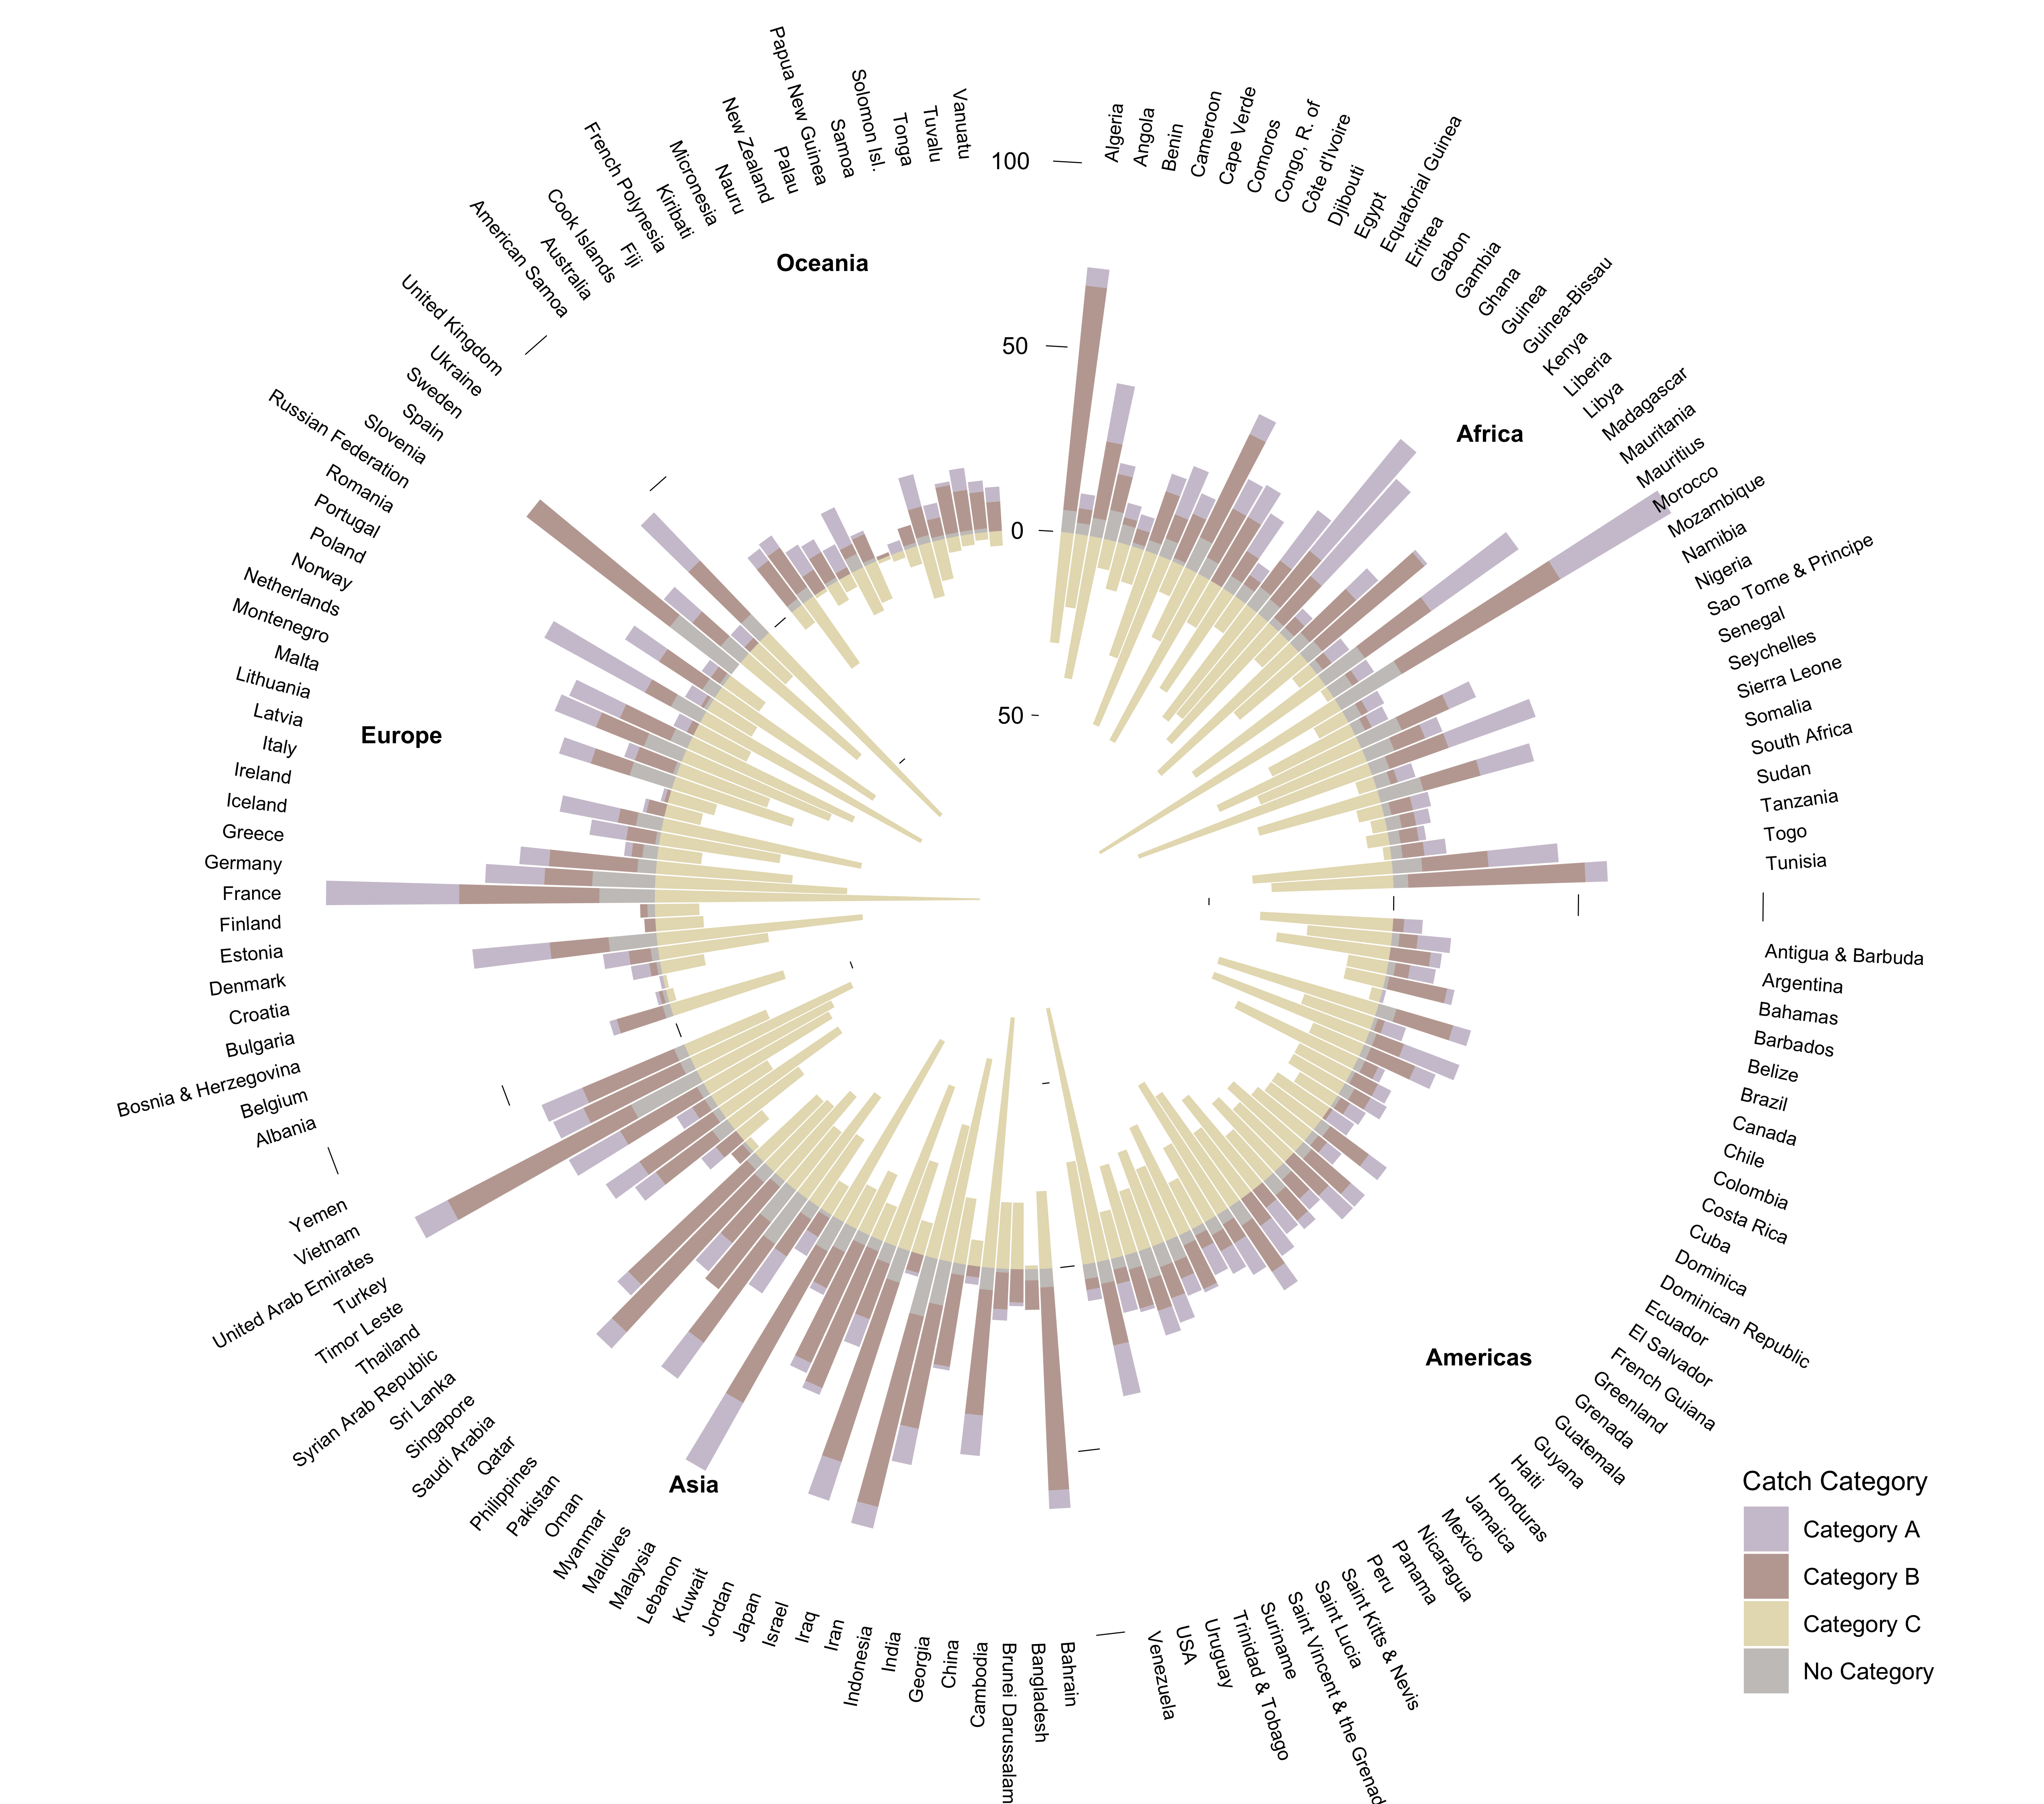

**Number of transboundary species by catch category, country, and continent. Category A, fishing between 10%-50% of max catch peak after a drop larger than 10% of max peak; Category B, fishing over 50% of max catch peak; Category C, fishing is between 10-50% of max catch peak or less than 10%**

While these catch trends do not directly reflect stock status - e.g. other factors like markets, fishing policies or extreme events also influence catch volume (*17*, *18*) - they could resemble fisheries that are over exploited or collapsed (*16*). Empirical analysis suggest that in most cases, management of transboundary species will have better outcomes in terms of fish yield when nations cooperate (*5*). Examples vary between regions and species including Mexico and the United States over Pacific anchovies (*19*), Norway and Russia over Atlantic cod (*Gadus morhua*) (*20*, *21*), and Namibia and South Africa over hake (*Merluccius spp*) (*22*). Collaboration can also reduce conflict between nations over shared resources. Transboundary fisheries are abundant and of economic importance for some of the top countries with past fisheries-related conflicts like Canada, the US, China and Russia (*23*). For example, the United States and Canada had a dispute over Pacific salmons (*Oncorhynchus sp*) that lasted over 10 years and was only resolved after these two nations set a series of regulations to compensate losses (*6*). Since 2007, the European Union, Norway, Iceland, and the Faroe Islands have been at odds over the size and relative allocation of total allowable catches (TACs) for Atlantic mackerel (*Scomber scombrus*) (*7*), a species that is transboundary and contributes **698.3** thousand tones to landings and USD **968** million in revenue to the countries involved in the dispute. In addition to past and present conflicts, climate change could exacerbate conflicts over transboundary species as climate change shifts the distribution of marine species around the globe (*8*).

Over 130 marine fish species occur in tropical and subtropical waters around the world (*2*) many of which are highly migratory pelagic-oceanic species. Not surprisingly, this is the only group that significantly differs in terms of sharing countries (one-way ANOVA *F*(5,109), *f* = 14.67, *p* < 0.001, $α$ = 0.05; Tukey’s post hoc test *p* < 0.05) with a median of 40 EEZs shared per species (Fig. 3).

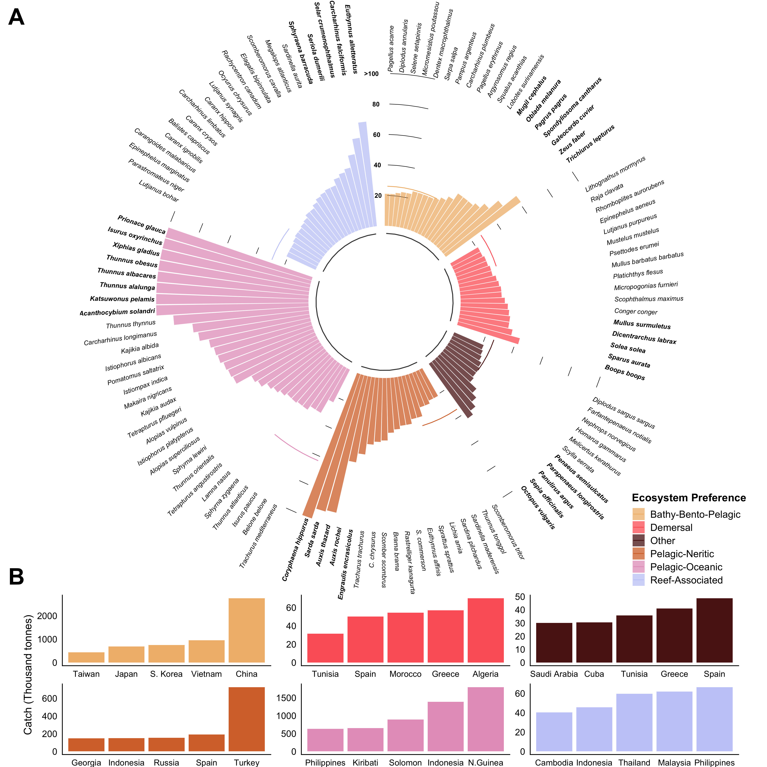

**Number of countries shared by transboundary species. Showing only species that share > 20 countries**

Due to their large migration patterns and presence in areas beyond national jurisdiction, pelagic species like skipjack tuna (*Katsuwonus pelamis*), Common dolphinfish (*Coryphaena hippurus*), and tunas (*Thunnus sp.*), are cataloged as straddling species and globally managed by Regional Fisheries Management Organizations (RFMOs). Fifteen major RFMOs in the world oversee the management of 99 species, most of them fished in areas beyond national jurisdiction (*24*). We estimate that 81.8% of these species (*n* = 81) are actually shared within neighboring RFMOs, with the International Commission for the Conservation of Atlantic Tunas (ICCAT) sharing over 40 species with neighboring RFMOs (**Supplemental figure RFMO_MAP**). The effectiveness of RFMOs responsible for managing high migratory stocks, has been previously questioned (*24*). However, a recent analysis of 13 species (40 stocks) suggests that most tuna and billfish stocks (e.g. marlins, swordfish, tunas) are sustainably harvested ( $B/B_{MSY}>1$ and $F/F_{MSY}<1$) despite some still experiencing overfishing (*25*). The catch from transboundary pelagic-oceanic species comes mainly from five Island Nations in the South Pacific, from which three (Kiribalti, Solomon and Papua New Guinea) are members of the Pacific Nauru Agreement (PNA) (Fig. 3B). The PNA manages 30% of global skipjack tuna (*26*), estimated to produce $2 billion worth of fish every year (**???**).

The median for species of all other ecosystem preferences is close to, or less than, 20, as many of these species have narrower/smaller distributions or are less mobile (e.g. *Solea solea*, *Panulirus argus*) (Fig. 3). However, less distributed species must not be ignored. The world of fisheries is highly connected trough larvae dispersal (*27*) and so, even centralized populations could be supplying populations thousands of kilometers away (*27*). Moreover, many coastal communities, specially in developing regions, and highly dependent on fishing local fish (e.g. reef fish) for food security and improved livelihoods (*28*, *29*). For example, from the top five countries fishing transboundary reef - associated species (Fig. 3B), Indonesia, Malaysia and the Philippines are among the highest fish consumption per capita in the world with 20, 60 and 40 kg per year, respectively (*30*).

Our study identifies the current species shared by two or more coastal nations and highlights the importance of these species in terms of global capture and revenue from wild fisheries. Our results show that captures and revenues from shared species are higher than previously estimated and particularly important to countries in Northern America and Eastern Asia. This result highlights the importance of these fisheries and their potential contribution to regional food security and wellbeing. Moreover, the vast majority of transboundary species are harvest at low rates with no geographic variation. Previous work has found that collaboration will result in better outcomes for shared marine resources. Thus, countries should pay specific attention in the management of the identified transboundary stocks potentially creating collaborative management plans. Identifying existing transboundary species is the first step towards joint management frameworks that are precautionary, strive for sustainability, and can be flexible to accommodate the uncertain future driven by climate change.

# Materials and Methods

We determine whether or not a species can be considered transboundary. The method is based on a series of criteria to be met and the overlay of species distributions and the spatial boundaries of the world’s EEZs. For the current analysis we work at the species level and adopt the Food and consider transboundary species as those that occur within the Exclusive Economic Zone (EEZ) of neighboring countries (*6*). All data was scaled to 0.5 degree latitude x 0.5 degree longitude grid cells (*n* = ~180,000 grid cells).

## Databases on species geographic distributions

To determine the number of transboundary marine species exploited by fisheries within each of the world’s EEZs we first extracted all the commercial marine fish or invertebrate species from the *Sea Around Us* database (<http://www.seaaroundus.org> and determined their current distributions. For this, we used four data sources of species-distributions: (*i*) observational data, (*ii*) an Environmental Niche Model (ENMs), (*iii*) a life-history-based distribution model, and (*iv*) fisheries catch data (**Table x**). Each source represent a different method of estimating the distribution of a given species and thus, provides a more robust result. Only commercial fished species with data from all four sources were included in the analysis. The final dataset comprised **XXX** species, **XX**% of the reported marine species in the SAU database and **XX**% of the reported taxa of the FAO (**See S1_Data**).

### *Occurence data*

The occurrence data was collected from five publicly available repositories; Fishbase (<http://fishbase.org>), the Global Biodiversity Information Facility (GBIF; <https://www.gbif.org/>), the Ocean Biogeographic Information System (OBIS; <https://obis.org/>), the Intergovernmental Oceanographic Comission (IOC; <http://ioc-unesco.org>), and the International Union for Conservation of Nature (IUCN; <https://www.iucn.org/technical-documents/spatial-data>) (*31*).

### *Distribution models*

In addition to the occurrence data we use two different methods to estimate species distributions, hereafter referred as ENM-Nereus and SDM-SAU. Although they use the same data, the models are structurally different complementing each other and providing robustness to the results.

The ENM-Nereus consists in a multimodel approach based on a Bioclim and a Bososted Regression Tree model (*32*), a Maxent model (*33*), and a Non-Parametric Probabilistic Ecological Niche Model (*34*). Environmental variables utilized in the models included sea surface temperature, surface pH, surface oxygen concentration, and vertically integrated (0–100 m) net primary production (NPP) (*12*). The ENM-Nereus employed all of the observational data-sources previously mentioned. Global environmental conditions were obtained from 1970 to 2000 and average from three Earth System Models developed by the Geophysical Fluid Dynamics Laboratory (GFDL- <https://www.gfdl.noaa.gov/earth-system-model/>), the Institute Pierre Simon Laplace (IPSL- www.icmc.ipsl.fr/), and the Max Planck Institute for Meteorology (MPI- www.mpimet.mpg.de/en/science/models/). See (*12*, *31*) for model details.

The SDM-SAU model follows a five-steps process based on species-specific life history information, rather than environmental variables (*35*, *36*). For each commercial fish species, the model first uses the FAO major fishing areas and countries EEZs to determine a broad distribution. It then uses life history information to delimit its range within the FAO fishing area (e.g. thermal preference, depth limits). The range is delimited even further by expert-review polygons and compared with that of AquaMaps (*37*), OBIS and GBIF occurrence data. The model then determines a species habitat preference based on the assumptions that the relative abundance of a species is determined by the number of habitats in a grid cell and the distance of the species to each habitat, as well as the importance of the habitat to the species size. Finally, the species equatorial submergence (e.g. the latitudinal region where a species is not seen in between poles) is estimated for each species. See (*35*, *36*) for model details.

### *Catch data*

The previous models combine observational data with a series of biotic and abiotic information to determine the probability that a species will be found in a given space at a given time. However, this does not mean that the species in question will actually be there. While the models do use approaches to double-check species occurrences (e.g. ENM-Nereus uses four different species distribution algorithms and SPD-SAU undertakes validation by means of other models), we used a fourth data source to corroborate the models’ outputs. The *Sea Around Us* estimates total reconstructed catches - i.e., catches based on all publicly available information sources and including discards, as well as unreported and illegal catches that are not included in the FAO data available for each country. Catches are also spatially allocated (*13*). Thus, we used the Sea Around Us catch reconstruction database from 2005 to 2014 (last ten years of data) as the fourth dataset to estimate transboundary species and to estimate their catch contribution within EEZs.

## Determine if a species is transboundary

We developed a four-criteria method for determining whether or not a species was transboundary. Only species that meet all criteria were considered as transboundary species and the analysis was done only within the EEZs of coastal states. In some cases, criteria also work as indexes to measure the uncertainty in the analysis as they provided continuous index (e.g. from 0 to 1) rather than a discrete, yes or no, index . All of the analysis was done in the statistical software *R version 3.5.2 (2018-12-20)* with the packages *data.table*(*38*), *janitor*(*39*), *wesanderson*(*40*), *rfishbase*(*41*), *R.matlab*(*42*), *sf*(*43*), *sp*(*44*), *tidiverse*(*45*), *tidytext*(*46*), and *zoo*(*47*). All code is available at <https://github.com/jepa/FishForVisa>.

### Criteria 1; Neighboring EEZs

As previously mentioned, we define transboundary species as those marine species that happen within the EEZs of two or more neighboring countries. Hence, the first criteria was that the species would only be transboundary between two neighboring countries, regardless of the species extended distribution. This way, a species such as Atlantic cod (*Gadus morhua*) distributed along the north Atlantic, was only considered transboundary between each of the neighboring nations covering its distribution, rather than the region as a whole. We assume that this would reduce the differences between species and stock as is more likely that neighboring species belong to the same stock, rather than, lets say, Cod in Norway and Canada. However, the analysis here presented was kept at the species level and stocks within countries were not considered.

We define the EEZ boundaries using the SAU shapefile (updated 1 July 2015, available from <http://www.seaaroundus.org>) that sub-divides EEZs by regions (e.g. Mexico Pacific and Mexico Atlantic) and determine the intersections between polygons using the *sf*-*R* package. When estimating transboundary species, we filter out those shared by the EEZs sub-regions, and when aggregating by country we only counted the species once, if it appeared in more than one sub-region. Species that were present in EEZs that were non-continental territories neighboring other countries were kept (e.g. Argentina and Falkland Islands), but removed when the non-continental territory belonged to the same nation (e.g. Brazil and Fernando de Noronha).

### Criteria 2; Data agreement

We use the occurrence database, the ENM-Nereus model, and SDM-SAU model to determine the presence of each species within each of the 0.5 x 0.5 grid cells. We computed a *Species Index* by dividing the number of datasets that confirm presence of a species in a grid cell over the total amount of datasets (*n* = 3). The index is unit-less and represents a scale from 0.3 to 1 where 0.3 means only one dataset reports presence of the species in a grid cell, 0.6 represents two of three sources, and 1 means agreement between all datasets. For the analysis, we selected only those cases where *Species Index* = 1 to get a more conservative estimate of transboundary species.

### Criteria 3; Modeling verification

We assume that a species was only present in a given grid-cell if it was reported in the SAU catch database. Therefore, all species that were not reported as caught in any single year between the reference years (2005 to 2014) in a given grid-cell were dropped, regardless of the *Species Index*. The assumption relies in that if a commercial species is projected within any fishing country, such species would have been fished, and thus reported at some period of time, thus validating the models.

### Criteria 4; Spatial distribution

Finally, in order to have a more robust result and do not determine a transboundary species based on the presence in a single 0.5 x 0.5 grid cell within an EEZ, we computed an *Area Index*. The *Area Index* consist in the proportion of the total species distribution within both EEZs that each neighboring EEZ has. We determine that a species would be transboundary if both neighboring EEZs enclosed over 25% of the species joint distribution. Such threshold can be lowered for a more relaxed result or increased for a more conservative estimate (**S2_Hist_per_Treshold**).

## Fisheries trends

We estimated the economic contribution of transboundary species for each country using global ex-vessel price (*48*). The data includes ex-vessel price from multiple sources and a structured interpolation method (e.g. similar countries, species) to fill in data gaps (*49*). The contribution of transboundary species was done by aggregating the catch of each species that happened within the EEZ of the countries sharing that species. For this study, we did not include catch nor revenue from areas beyond national jurisdiction. Finally, we use the catch data to determine the exploitation category of each species within a EEZ. Although this method has previously used to estimate stock status (*50*), the categories presented here are intended to be seen as catch trends, and not status of each species. We only assessed species within each EEZ that had at least ten years of data between the first and last reported landings with at least five consecutive data years. Three categories were drawn from a method depending on the year’s catch, the maximum catch over time and the minimum catch after the catch peak (**Table XX**) (*16*). Finally, we reported the predominant category over the last ten years of catch data (2005-2014). We perform a series of one-way analysis of variance ( one-way ANOVA) to determine significant differences (statistically) between the means of different groups (e.g. categories, regions, species) regarding transboundary species and their contribution in terms of catch and revenue.

## Caveats

# Supplements

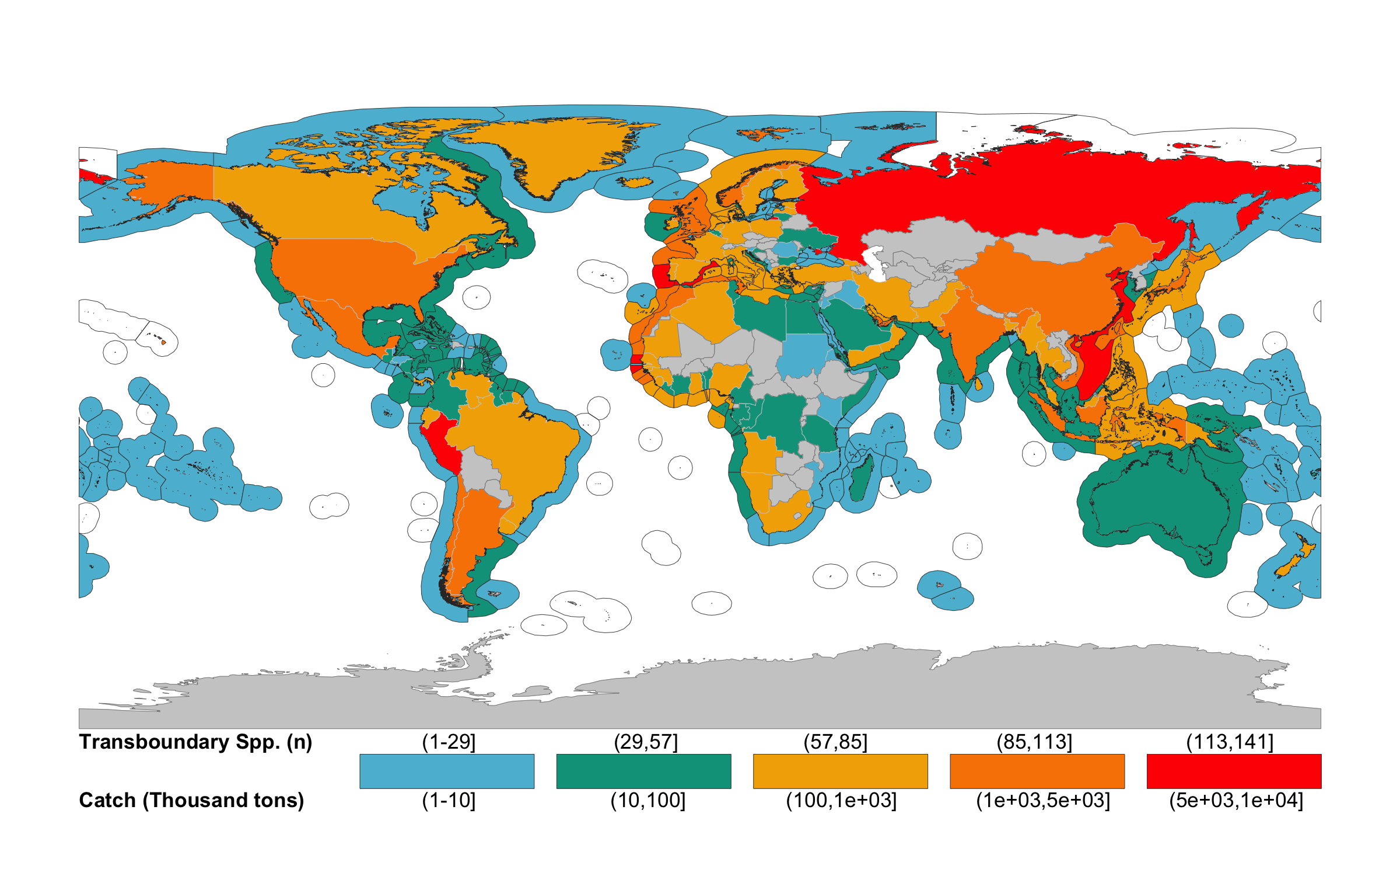

**Number of transboundary species per EEZ and they contribution to countries’ EEZ catch. The number of species is represented in the EEZ while the catch (thousand tonnes) is represented in the land polygon.**

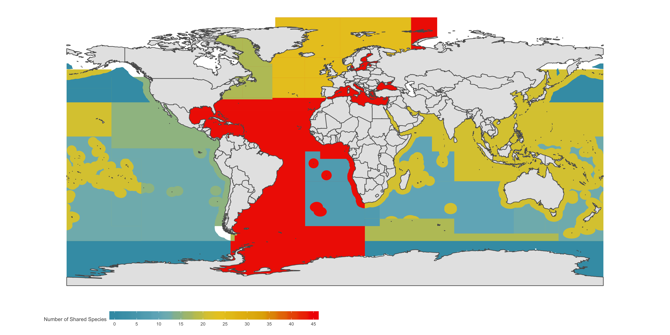

**Number of shared species by RFMOs. Analysis included with 99 species managed by Fourteen RFMOs**

It is expected that the number of gridcells where a species is present (*Area Index*) would directly influence whether or not a species is considered transboundary. Therefore, we tested the sensitivity of our results to the *Area Index* by estimating the number of transboundary species along a gradient of values (*S3 Index Area*). As expected, using a more relaxed value (e.g. the species is present within 10% or more of the EEZ) will result in more transboundary species giving a median of 40 EEZs shared per species, while a more strict value (e.g. 50%) will give a median of 4. For the current analysis we presented the results using a 25% *Area Index* threshold (*S3 Index Area* - darker histogram).

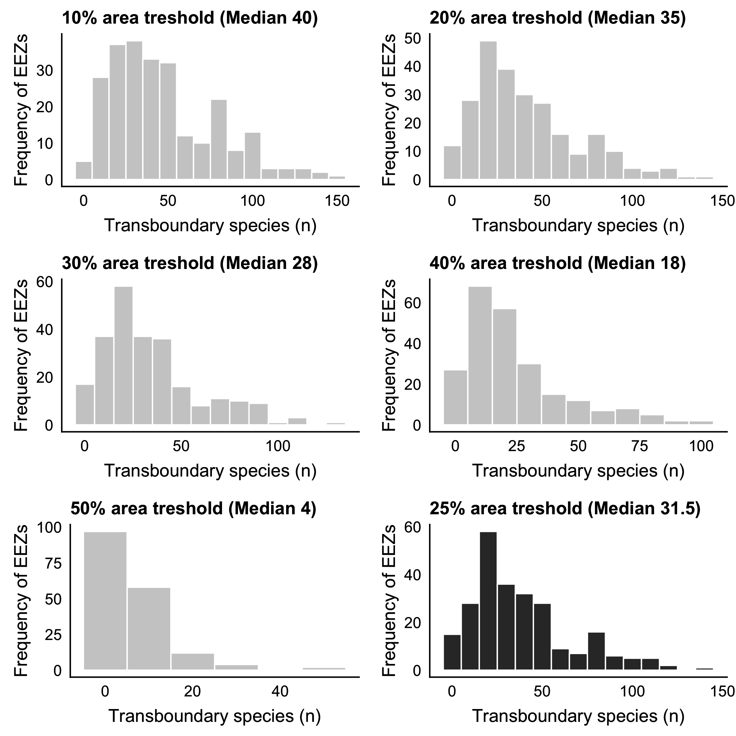

**Histogram of transboundary species using different values of Area Index. Darker histogram represents used value (25%) in the analysis**

**References**

1. G. E. Hutchinson, Concluding remarks. *Cold Spring Harbor Symposium on Quantitative Biology*, 1–13 (1957).

2. J. S. Nelson, T. C. Grande, M. V. H. Wilson, *Fishes of the World* (John Wiley & Sons, Inc, Hoboken, NJ, USA, 2016), *Nelson/fishes of the world*.

3. A. M. Song, J. Scholtens, J. Stephen, M. Bavinck, R. Chuenpagdee, Transboundary research in fisheries. *Marine Policy*. **76**, 8–18 (2017).

4. A. Fredston-Hermann, S. D. Gaines, B. S. Halpern, Biogeographic constraints to marine conservation in a changing climate. *Annals of the New York Academy of Sciences*. **367**, 49–13 (2018).

5. M. Bailey, U. Rashid Sumaila, M. Lindroos, Application of game theory to fisheries over three decades. *Fisheries*. **102**, 1–8 (2010).

6. K. Miller, G. Munro, *Cooperation and Conflicts in the Management of Transboundary Fishery Resources* (Proceeding of the Second World Conference of the Second World COngress of the American; European Associations of Environmental; Resource Economics, Monterey, California, 2002).

7. J. Spijkers, W. J. Boonstra, Environmental change and social conflict: the northeast Atlantic mackerel dispute. *Regional Environmental Change*. **17**, 1835–1851 (2017).

8. M. L. Pinsky *et al.*, Preparing ocean governance for species on the move. *Science*. **360**, 1189–1191 (2018).

9. K. A. Miller, G. R. Munro, U. R. Sumaila, W. W. L. Cheung, Governing Marine Fisheries in a Changing Climate: A Game-Theoretic Perspective. *Canadian Journal of Agricultural Economics/Revue canadienne d’agroeconomie*. **61**, 309–334 (2013).

10. J. Caddy, Establishing a consultative mechanism or arrangement for managing shared stocks within the jurisdiction of contiguous states. *Australian Society for Fish Biology* (1997).

11. L. S. L. Teh, U. R. Sumaila, Trends in global shared fisheries. *Marine Ecology Progress Series*. **530**, 243–254 (2015).

12. R. G. Asch, W. W. L. Cheung, G. Reygondeau, Future marine ecosystem drivers, biodiversity, and fisheries maximum catch potential in Pacific Island countries and territories under climate change. *Marine Policy*. **88**, 285–294 (2018).

13. D. Zeller *et al.*, Still catching attention: Sea Around Us reconstructed global catch data, their spatial expression and public accessibility. *Marine Policy*. **70**, 145–152 (2016).

14. K. Kleisner, D. Zeller, R. Froese, D. Pauly, Using global catch data for inferences on the world’s marine fisheries. *Fish and Fisheries*. **14**, 293–311 (2013).

15. FAO, The state of world fisheries and aquaculture: Meeting the sustainable development goals, 1–227 (2018).

16. K. Kleisner, D. Pauly, in *The state of biodiversity and fisheries in regional seas*, V. Christensen, S. Lai, M. L. D. Palomares, D. Zeller, D. Pauly, Eds. (The Fisheries Center, UNiversity of British Columbia; Fisheries Centre Research Reports, 2011), pp. 37–40.

17. D. Pauly, R. Hilborn, T. A. Branch, Fisheries: Does catch reflect abundance? *Nature*. **494**, 303–306 (2013).

18. T. A. Branch, Not all fisheries will be collapsed in 2048. *Marine Policy*. **32**, 38–39 (2008).

19. A. M. Cisneros-Montemayor, G. Ishimura, G. R. Munro, U. R. Sumaila, Ecosystem-based management can contribute to cooperation in transboundary fisheries: The case of pacific sardine. *Global Environmental Change*. **221**, 105401 (2020).

20. F. K. Diekert, D. Ø. Hjermann, E. Nævdal, N. C. Stenseth, Non-cooperative exploitation of multi-cohort fisheriesThe role of gear selectivity in the North-East Arctic cod fishery. *Resource and Energy Economics*. **32**, 78–92 (2010).

21. A. Eide, K. Heen, C. Armstrong, O. Flaaten, A. Vasiliev, Challenges and Successes in the Management of a Shared Fish Stock The Case of the RussianNorwegian Barents Sea Cod Fishery. *Acta Borealia*. **30**, 1–20 (2013).

22. U. R. Sumaila, C. Ninnes, B. Oelofsen, in *Papers presented at the norway-fao expert consultation on the management of shared fish stocks* (2003), pp. 143–159.

23. J. Spijkers *et al.*, Global patterns of fisheries conflict: Forty years of data. *Global Environmental Change*. **57**, 101921 (2019).

24. S. Cullis-Suzuki, D. Pauly, Failing the high seas: A global evaluation of regional fisheries management organizations. *Marine Policy*. **34**, 1036–1042 (2010).

25. M. Pons *et al.*, Effects of biological, economic and management factors on tuna and billfish stock status. *Fish and Fisheries*, 1–21 (2016).

26. T. Aqorau, J. Bell, J. N. Kittinger, Good governance for migratory species. *Science*. **361**, 1208–1209 (2018).

27. N. Ramesh, J. A. Rising, K. L. Oremus, The small world of global marine fisheries: The cross-boundary consequences of larval dispersal. *Science*. **364**, 1192–1196 (2019).

28. A. M. Cisneros-Montemayor, D. Pauly, L. V. Weatherdon, Y. Ota, A Global Estimate of Seafood Consumption by Coastal Indigenous Peoples. *PLoS ONE*. **11**, e0166681 (2016).

29. R. B. Cabral, R. C. Geronimo, How important are coral reefs to food security in the Philippines? Diving deeper than national aggregates and averages. *Marine Policy*. **91**, 136–141 (2018).

30. S. Foale *et al.*, Food security and the Coral Triangle Initiative. *Marine Policy*. **38**, 174–183 (2013).

31. G. Reygondeau, in *Predicting future oceans sustainability of ocean and human systems amidst global environmental change*, W. W. L. Cheung, Y. Ota, D. P. L. V. W. Y. O. Andrés M Cisneros-Montemayor, Yos, Eds. (Oxford, UNited Kingdom, 2019), pp. 87–99.

32. W. Thuiller, B. Lafourcade, R. Engler, M. B. Araújo, BIOMOD - a platform for ensemble forecasting of species distributions. *Ecography*. **32**, 369–373 (2009).

33. S. J. Phillips, R. P. Anderson, R. E. Schapire, Maximum entropy modeling of species geographic distributions. *Ecological Modelling*. **190**, 231–259 (2006).

34. G. Beaugrand, S. Lenoir, F. Ibanez, C. Manté, A new model to assess the probability of occurrence of a species, based on presence-only data. *Marine Ecology Progress Series*. **424**, 175–190 (2011).

35. C. Close *et al.*, Distribution ranges of commercial fishes and invertebrates. p. *Fishes in Databases and …* (2006).

36. M. Palomares, W. W. L. Cheung, V. W. Y. Lam, D. Pauly, in *Challenges and successes in the management of a shared fish stock the case of the russianNorwegian barents sea cod fishery*, D. Pauly, D. Zeller, Eds. (books.google.com, London, U.K, 2016).

37. K. Kaschner *et al.*, AquaMaps: Predicted range maps for aquatic species (2016), (available at www.aquamaps.org).

38. M. Dowle *et al.*, Package data.table; Extension of ‘data.frame‘. **R (>= 3.1.0)** (2019).

39. S. Firke, C. Haid, R. Knight, B. Denney, Package janitor; Simple tools for examining and cleaning dirty data. **R (>= 3.1.2)** (2018).

40. K. Ram, H. Wickham, C. Richards, A. Baggett.

41. C. Boettiger, S. Chamberlain, D. T. Lang, P. Wainwright, Package rfishbase; R Interface to ’FishBase’. **R (>= 3.0)** (2019).

42. H. Bengtsson, A. Jacobson, J. Riedy.

43. E. Pebesma *et al.*, Package sf; Simple Features for R. **R (>= 3.3.0)** (2018).

44. E. Pebesma *et al.*, Package sp; Classes and methods for Spatial Data. **R ( $≥$ 3.0.0)** (2019).

45. H. Wickham, Package tidyverse; Easily Install and Load the ’Tidyverse’. **R (3.5.0)** (2017).

46. G. De Queiroz *et al.*

47. A. Zeileis, G. Grothendieck, J. A. Ryan, J. M. Ulrich, F. Andrews.

48. T. C. Tai, T. Cashion, V. W. Y. Lam, U. R. Sumaila, Ex-vessel fish price database: disaggregating prices for low-priced species from reduction fisheries. *Frontiers in Marine Science*. **4**, 1–10 (2017).

49. U. R. Sumaila, L. Teh, D. Zeller, D. Pauly, The global ex-vessel fish price database. In: D. Pauly and D. Zeller (eds). Catch reconstructions: concepts, methods and data sources. Online Publication (2015), (available at <http://www.seaaroundus.org/catch-reconstruction-and-allocation-methods/#_Toc421534369>).

50. R. J. R. Grainger, S. M. Garcia, “Chronicles of marine fishery landings (1950 1994) trend analysis and fisheries potential” (359, Rome, Italy, 1996).